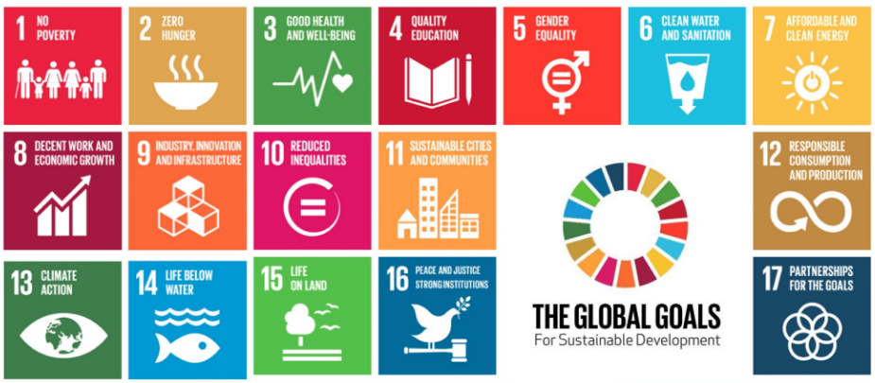
________________________________________________________________________________________________________________________________________________________________________________________________________________________________________________________________________________________________________________________________________________________________________________________________________________________________________________
Rich Nigeria still struggles
Despite now being classified as a Newly Emerging Economy (NEE) by the World Bank and having the highest GDP of all African countries, and Nigeria still struggles with development. It has failed several of the Millennium Development Goals and without help could fail some of the new Sustainable Development Goals set for 2030. Is aid still the answer? Or can they help themselves?

DOES NIGERIA STILL NEED AID?

______________________________________________________________________________________________________________________________________________________________________________________________________________________________________________________________________________________________________________________________________________________________________________________________________________________________________________________________________________________________________________________________________________________________________________________________________________________________________________________________________________________________________________________________________________________________________________________________________________________________________________________________________________________________________________________________________________________________________________________________________________________________________________________________________________________________________________________________________________________________________________________________________________________________________________________________________________________________________________________________________________________________________________________________

Editor:

Editorial ________________________________________________________________________________________________________________________________________________________________________________________________________________________________________________________________________________________________________________________________________________________________________________________________________________________________________________________________________________________________________________________
FEHS Geography News
24 February 2017
In 1990, Nigeria was the most indebted African country, owing $36bn to other nations and organisations. _____________________________ ________________________________________________________________________________________________________________________________________________________________________
