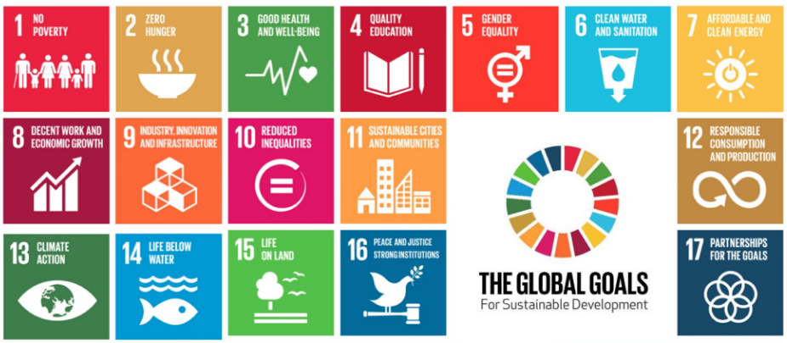
<<<Which SDGs is Nigeria failing with? Use the statistics gained from class to summarise>>>
Your text can go here. Your text can go here. Your text can go here. Your text can go here. Your text can go here. Your text can go here. Your text can go here. Your text can go here. Your text can go here. Your text can go here. Your text can go here. Your text can go here. Your text can go here. Your text can go here. Your text can go here. Your text can go here.
Rich Nigeria still struggles
Despite now being classified as a Newly Emerging Economy (NEE) by the World Bank and having the highest GDP of all African countries, and Nigeria still struggles with development. It has failed several of the Millennium Development Goals and without help could fail some of the new Sustainable Development Goals set for 2030. Is aid still the answer? Or can they help themselves?

DOES NIGERIA STILL NEED AID?

<<<For the main part of the article, research what WaterAid do to help Nigeria. Use your classnotes to summarise the type of aid they give and which SDGs they work towards. Explore the WaterAid Nigeria website and Twitter feed to fill your article with plenty of place-specific facts and information about the work they do>>>
Your text can go here. Your text can go here. Your text can go here. Your text can go here. Your text can go here. Your text can go here. Your text can go here. Your text can go here. Your text can go here. Your text can go here. Your text can go here. Your text can go here. Your text can go here. Your text can go here. Your text can go here. Your text can go here. Your text can go here. Your text can go here. Your text can go here. Your text can go here. Your text can go here. Your text can go here. Your text can go here. Your text can go here. Your text can go here. Your text can go here. Your text can go here. Your text can go here. Your text can go here. Your text can go here. Your text can go here. Your text can go here. Your text can go here. Your text can go here. Your text can go here. Your text can go here. Your text can go here. Your text can go here. Your text can go here. Your text can go here. Your text can go here. Your text can go here. Your text can go here. Your text can go here. Your text can go here. Your text can go here. Your text can go here. Your text can go here. Your text can go here. Your text can go here.

NEWSPAPER TITLE
Editor:
(Your name here)

Editorial
<<<Conclude whether you think Nigeria still needs a helping hand or not>>
Your text can go here. Your text can go here. Your text can go here. Your text can go here. Your text can go here. Your text can go here. Your text can go here. Your text can go here. Your text can go here. Your text can go here. Your text can go here. Your text can go here. Your text can go here. Your text can go here. Your text can go here. Your text can go here.
FEHS Geography News
13 February 2017
In 1990, Nigeria was the most indebted African country, owing $36bn to other nations and organisations.
<<<What has happened since? How could this help? Use your class notes>>>
