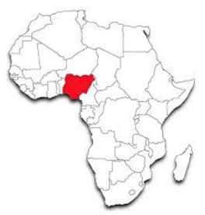
3.2 Challenges in the human environment - 3.2.2 Section B: The changing economic world
Economic Development in Nigeria (an African NEE)
Aid & Debt in Nigeria

STARTER: Types of aid – BINGO!
Choose 6 from the following:

- Official development assistance (ODA)
- Multilateral aid
- Bilateral aid
- Voluntary aid
- Short-term emergency aid
- Long-term development aid
- Bottom-up
- Top-down
- World Bank & International Monetary Fund (IMF)

NB: You can revise the types of aid from many sources like your revision book p85 and websites like http://www.bbc.co.uk/bitesize/standard/geography/international_issues/aid/revision/1/
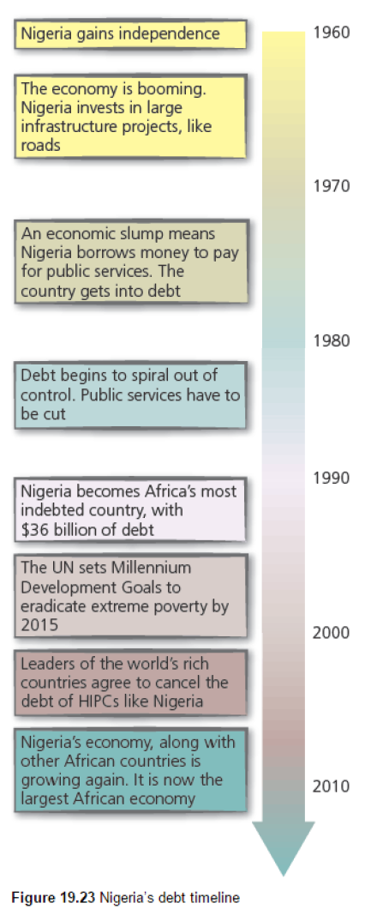
Nigeria’s progress towards the Sustainable Development Goals:
GOAL | Latest data | Trend | On target by 2030?
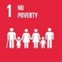 | % below poverty line (<$1.90/day), 2009:  53.5 |  | 
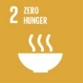 | % undernourished, 2016:  7.0
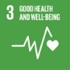 | Under 5 mortality rate (per 1000), 2015: |  | 
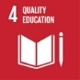 | % primary teachers had basic training, 2010:
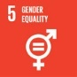 | % seats in parliament are women, 2016:
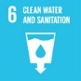 | % population with improved water, 2015:
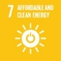 | % population with electricity, 2015:
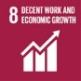 | % unemployment, 2014:
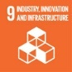 | % population covered by 2G network, 2014:
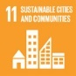 | % urban population living in slums, 2014:
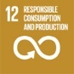 | Raw material footprint per capita (tonnes), 2010:
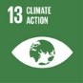 | Climate risk strategy in legislation etc?  2015:
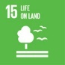 | % total land area covered in forest, 2015:
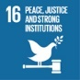 | % imprisoned who are unsentenced, 2015:
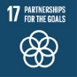 | % with access to the internet, 2015:
Not enough data for goals 10 and 14


WaterAid in Nigeria
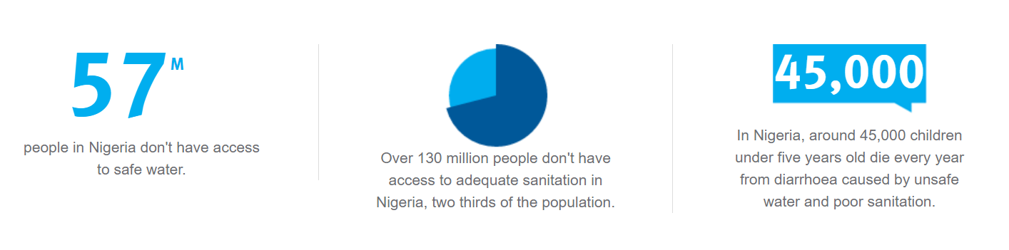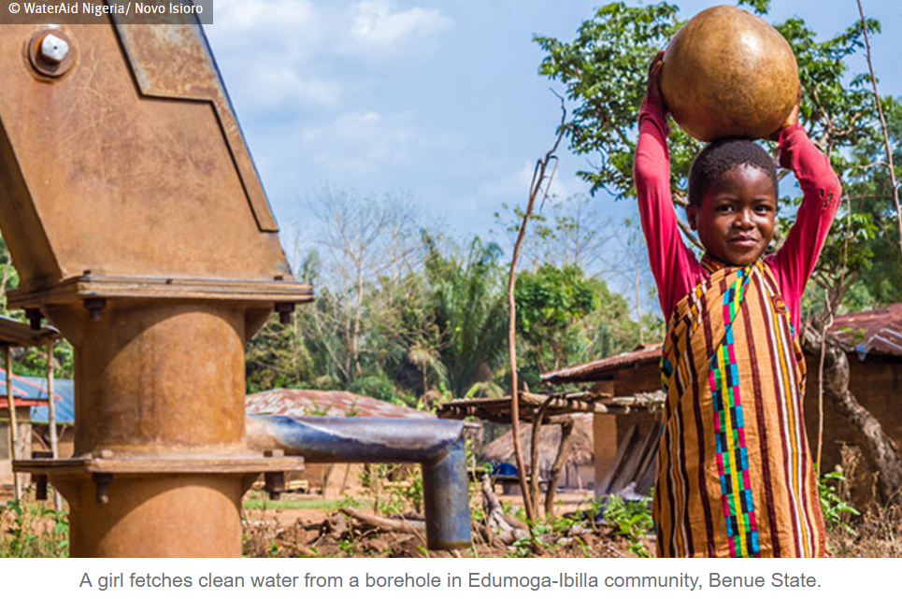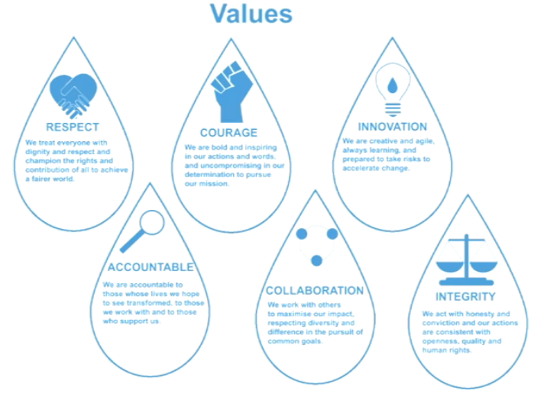
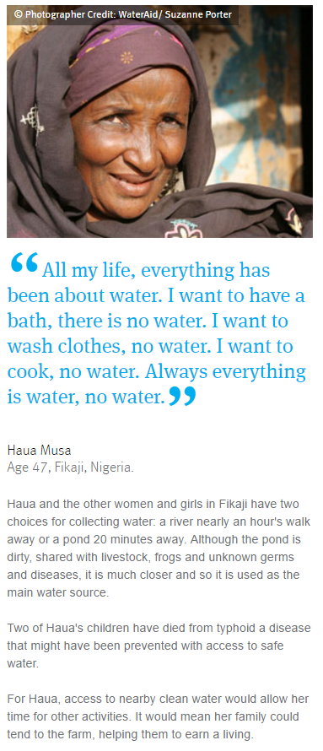
Quick questions:
- What types of aid do these projects represent?
- Which of the SDGs can WaterAid help Nigeria to achieve?
- Name three ways access to safe/improved water can help improve quality of life.
- Briefly describe WaterAid’s new WASH strategy for Nigeria

