HELP/ANSWERS for London Virtual Trip:

- Traffic congestion causes pollution as vehicles are still using fuel even though they are not travelling very far – so it is very wasteful. Loss of income is caused as people spend more time on the road which could end up being late for work, or to deliver something. The wasted fuel also costs money.
- Dualling of the rest of the A11 will save £690m in lost time. People will be able to get between London and Norwich quicker. Deliveries can be made quicker. There will be less congestion.

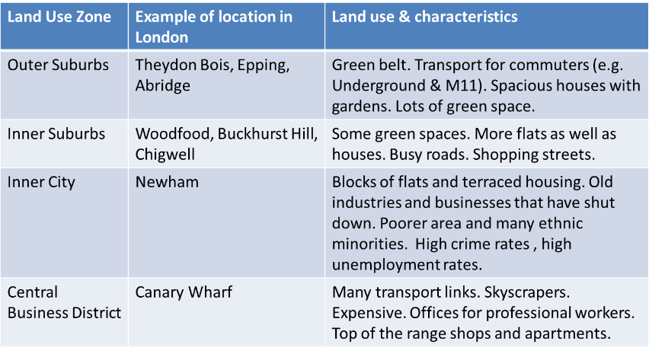

- The building materials in Canary Wharf used are marble, polished granite, reinforced steel and laminated glass. Buildings are very tall. This is a very expensive piece of land.
- Canary Wharf is mainly for highly-paid professional workers who do jobs in e.g. the financial sector. They have won from this development as there are plenty of jobs for them and places to live, shop and eat which only they can afford.
- Less skilled manual workers such as the “dockers” have lost. They used to work here unloading ships for little money and lived nearby. But the docks closed down as they were too small for big container ships. When they got redeveloped, it was more suitable for richer people – no jobs for the old dockers.
- There is evidence of ‘integrated transport’ in Canary Wharf, e.g. the DLR tram and the London Underground link together. There are also roads into the area for cars, buses and taxis.
- The map below shows the suggested answers, students may be slightly different and probably have used their own choice of colours.
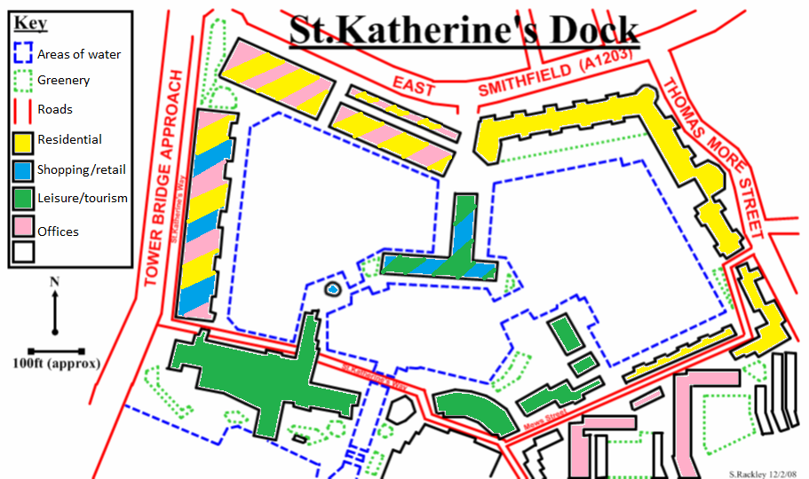
- Sketches should be CLEAR and done in PENCIL. They do not have to be an artist’s impression so long as the image is recognisable.
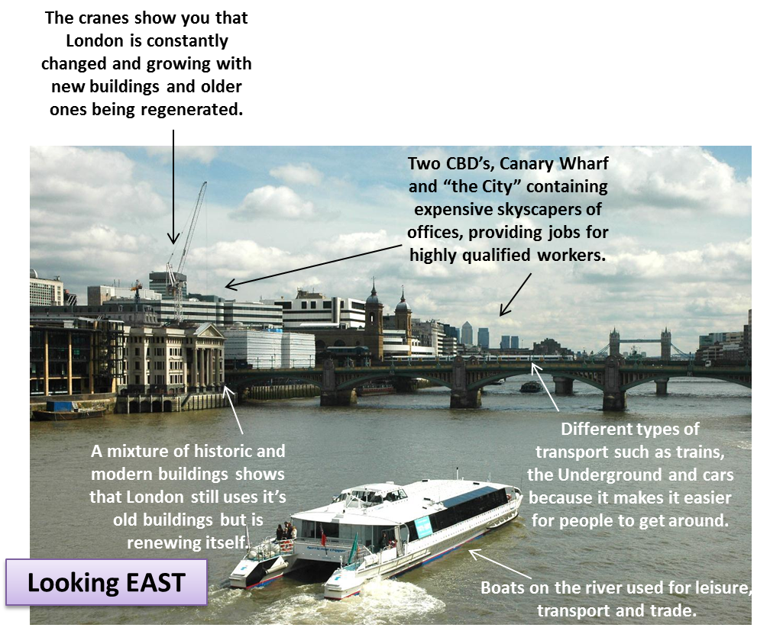
- Coin Street is different to Canary Wharf because Coin Street has been redeveloped by local people (the CSBC) while Canary Wharf by businesses and the Government. Canary Wharf is for professional workers who are highly paid, but Coin Street is for local people to live and work. Coin Street contains shops and services for different kinds of people, the shops at Canary Wharf are only really affordable by highly paid professionals.

